Practicum Case | 
COMP7116 | COMP7116001 | COMP7116016 | MATH6168 | MATH6168016
Computer Vision
Computer Science | O211-COMP7116-TD01-02
Valid on Odd Semester 2020/2021 | Revision 00

Outcomes
- Various computational principles and standard image processing operators in computer vision
- The local features with their detectors and descriptors in computer vision
- Various features to find correspondence between images and perform recognition in computer vision
- Various image recognition system in computer vision

Topics
- Session 2 – Statistical Descriptions of Image

Subtopics
- Histogram Equalization
- Plotting
Statistical Descriptions of Image
In this course we will learn how to use our analysis of image’s statistical properties, the analysis of the statistical properties of images is dictated by the concern of adapting secondary treatments such as filtering, restoring, coding, and shape recognition to the image signal. To properly understand and make use of the statistical properties, we need to fully understand how to plot the properties itself. For example, we can use a graphical display called a histogram. A histogram is an approximate representation of the distribution of numerical or categorical data. In computer vision, we mainly use the histogram as a graphical representation of the intensity distribution of an image, In simple terms, it represents the number of pixels for each intensity value considered.
After we understand the histogram, we will also learn about histogram equalization in this course. Histogram equalization is a computer image processing technique used to improve contrast in an image. It accomplishes this by effectively spreading out the most frequent intensity values, i.e. stretching out the intensity range of the image. This method usually increases the global contrast of images when its usable data is represented by close contrast values. This allows areas of lower local contrast to gain a higher contrast.

Before we start, make sure to install and import python libraries bellow.
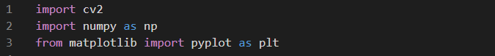
Figure 1. Importing libraries

In this course we will need opencv to do the histogram equalization, numpy for the ndarray, and matplotlib for the plotting. We will start by changing the color space into grayscale to plot the intensity to the histogram.

- Change the color space
There are more than 150 color-space conversion methods available in OpenCV. But in this course, we will only use BGR to Gray. To do so, we can look at the bellow example.
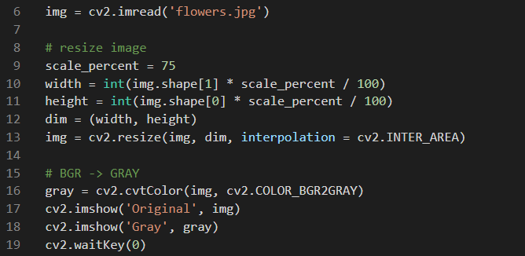
Figure 2. Resizing and changing the color space
As we can see from the above code, we can also use opencv to change the color space of our image. And in the above example we resized the image before changed the color space, because the image we use in this example is too big. Remember, resizing the image does not correlate with changing the color space. So, resizing the image is optional.
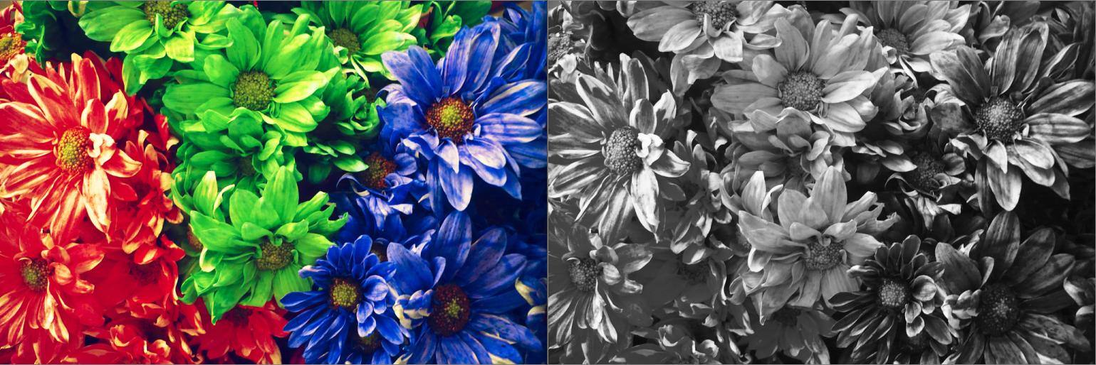
Figure 3. Before and after the color space changed

- Plot the intensity
To plot the number of pixels for each intensity. We need to count the pixels for each intensity and store it into our ndarray. After we get the number of pixels for each intensity, we can use matplotlib to start constructing our plot.
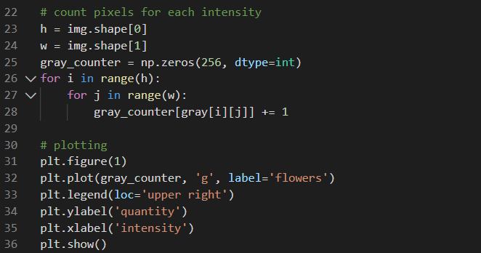
Figure 4. Plotting the number of pixels for each intensity
In the above example, we made one new array that represents every intensity in our image. Every time we counter a pixel with a certain intensity, we will increment the value in our array. After we got the number of pixels for each intensity, we can use pyplot to construct and display our plot.
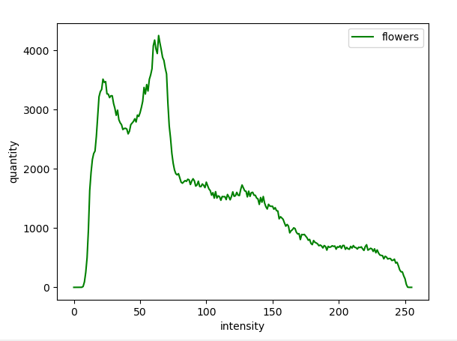
Figure 5. A plot of the number for each intensity

- Histogram equalization
After we have done with plotting our image, we can apply the histogram equalization to it. We need to keep our image before to see the difference after histogram equalization is applied. To do the histogram equalization we will use the function brought by opencv library. We can apply the function to our image, and just redo how we count the pixels for each intensity.
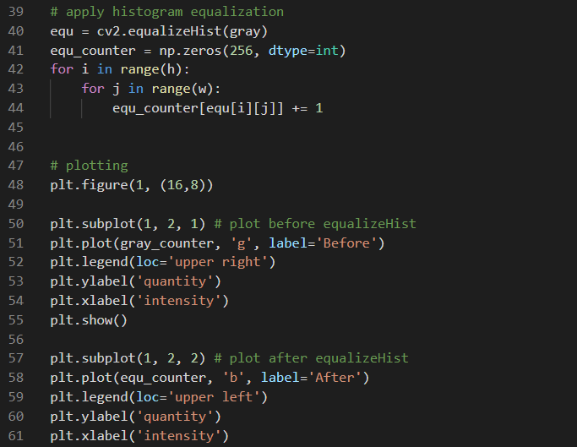
Figure 6. Applying and plotting the histogram equalization
In the above code, we made a new array to store the pixels for each intensity. After we got the number of pixels for each intensity, we display our new plot side by side with the plot we got before. To display the plot side by side, we can use the “.figure()” method from “matplotlib.pyplot”. The first parameter is the figure number, and the second parameter is the figure size in inches. Remember, to determine the position of each plot we can use the “.subplot()” method. The first parameter of the subplot method represents the number of rows, the second parameter represents the number of columns, and the third parameter is the index of the subplot.
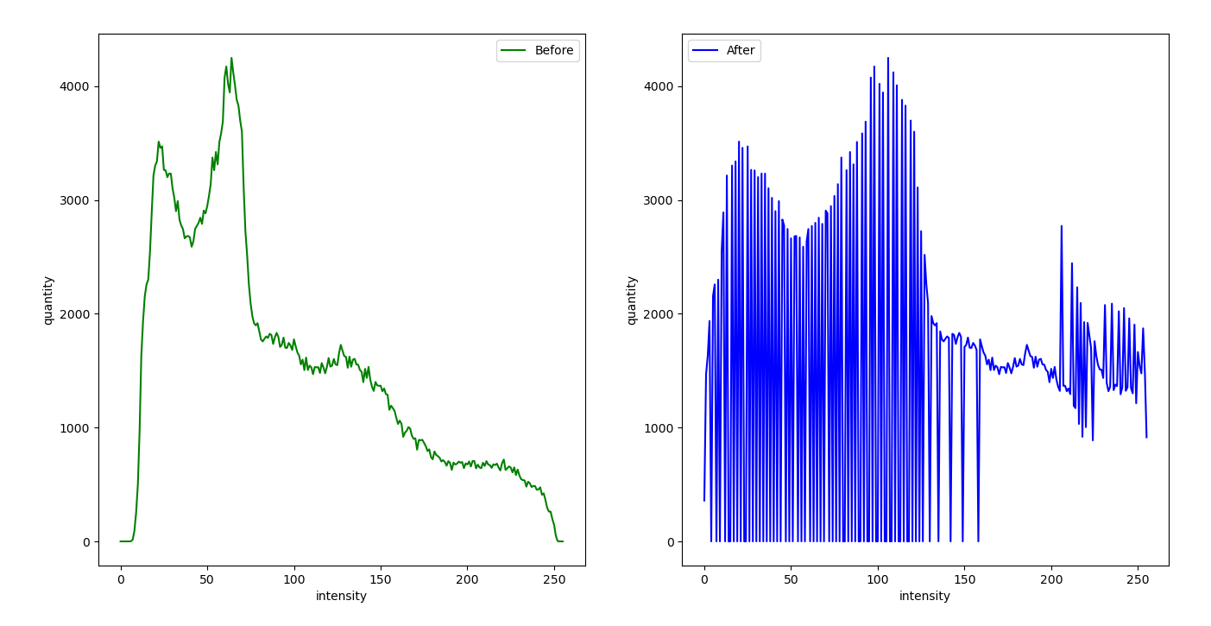
Figure 7. Plot before and after histogram equalization applied
After we can see the comparison of the image before and after applying the histogram equalization. We can display the image itself to compare the difference between before and after the histogram equalization using the code below.
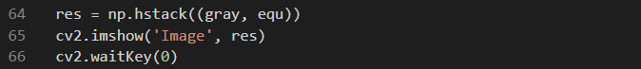
Figure 8. Showing before and after images
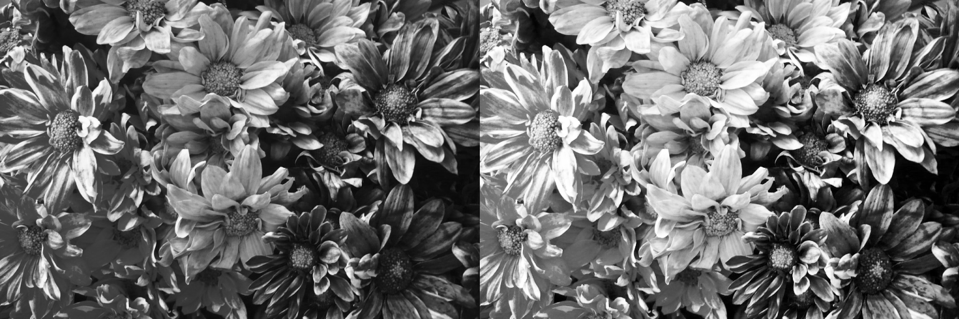
Figure 9. Before and after images
References:
https://www.flickr.com/photos/alfon18/2493066758

